**DAILY ONLINE ACTIVITIES SUMMARY**

|  |  |  |  |  |  |  |  |  |
| --- | --- | --- | --- | --- | --- | --- | --- | --- |
| **Date:** | **28-05-2020** | | | | | **Name:** | **Javahar.S.Goutham** | |
| **Sem & Sec** | **7 th B** | | | | | **USN:** | **4AL16CS132** | |
| **Online Test Summary** | | | | | | | | |
| **Subject** | | **System modelling and simulation(sms)** | | | | | | |
| **Max. Marks** | | **60** | | **Score** | | | **60** | |
| **Certification Course Summary** | | | | | | | | |
| **Course** | **Introduction to ethical hacking(completed)** | | | | | | | |
| **Certificate Provider** | | | **GreatLearing** | | **Duration** | | | **6 hrs** |
| **Coding Challenges** | | | | | | | | |
| Problem Statement:  1. Given an array A of size N where the array elements contain values from 1 to N with duplicates, the task is to find total number of subarrays which start and end with the same element.  2. Write a program in C to print all permutations of a given string using pointers.  3. Python Program to Print all Integers that Aren’t Divisible by Either 2 or 3 and Lie between 1  and 50 4. Python Program to Check if a Number is a Palindrome.5. Python Program to Count the Number of Digits in a Number.6. Python Program to Read a Number n And Print the Series "1+2+…..+n= ".  |  |  | | --- | --- | | Inbox | x | | | | | | | | | |
| **Status: YES, Completed all Programs** | | | | | | | | |
| **Uploaded the report in Github** | | | | | **YES** | | | |
| **If yes Repository name** | | | | | https://github.com/alvas-education-foundation/Goutham-dotcom | | | |

Online Test Details: (Attach the snapshot and briefly write the report for the same)

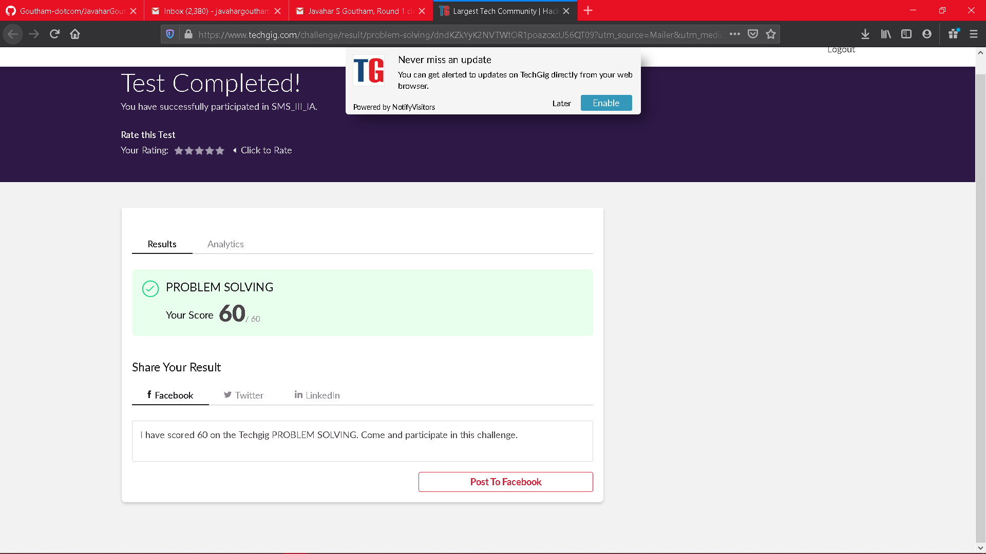

Scored 60 out of 60 in sms 3nd I.A test

Certification Course Details: (Attach the snapshot and briefly write the report for the same)

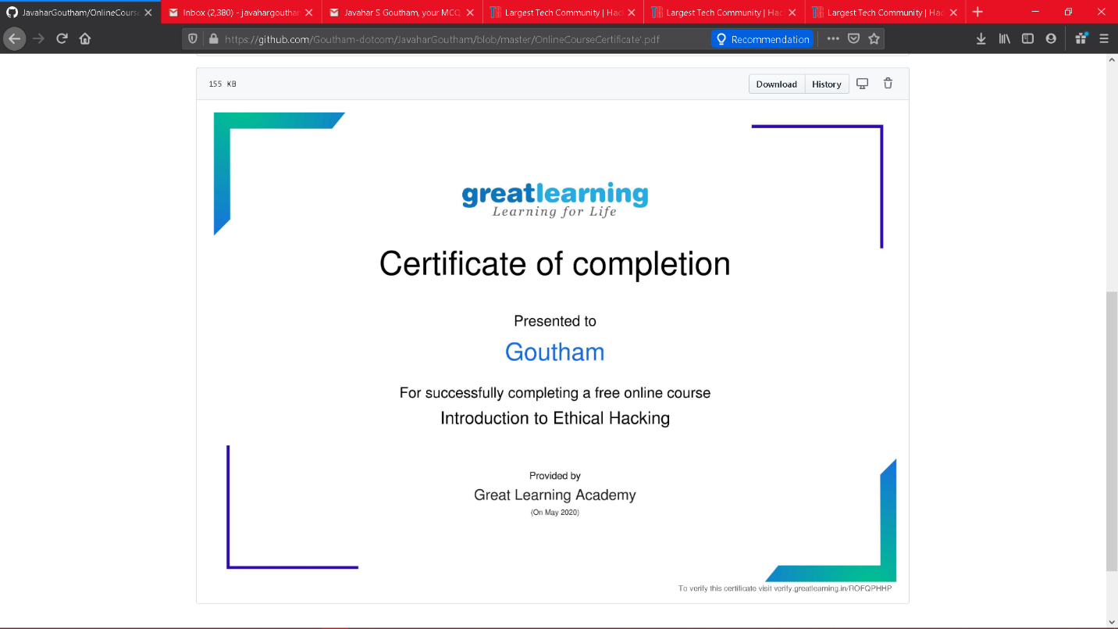

The above course is being taken up by me which is based on the Introduction to ethical hacking The details of the course and certificate provider is mentioned in the above form.

Coding Challenges Details: (Attach the snapshot and briefly write the report for the same)

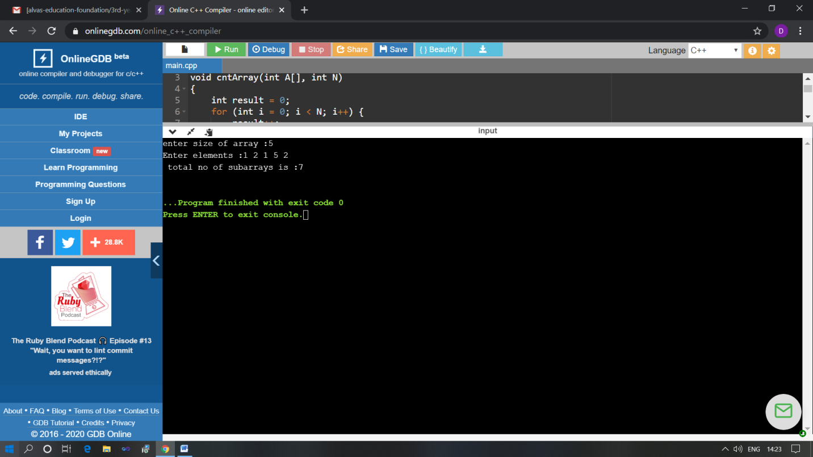

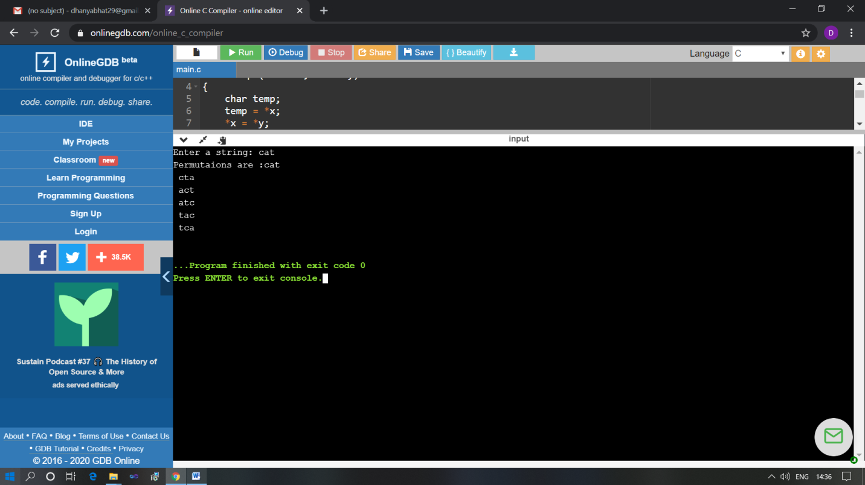

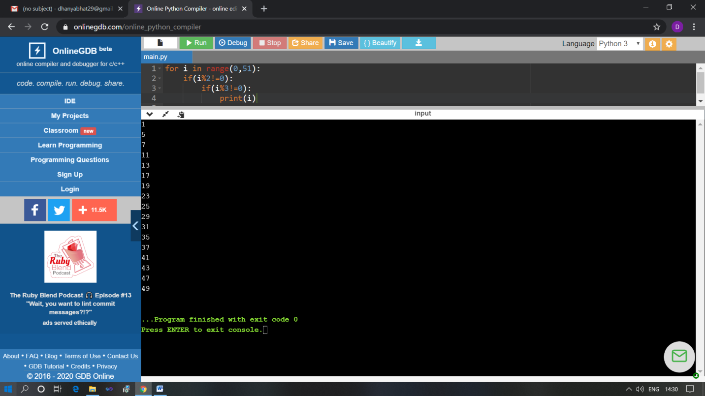

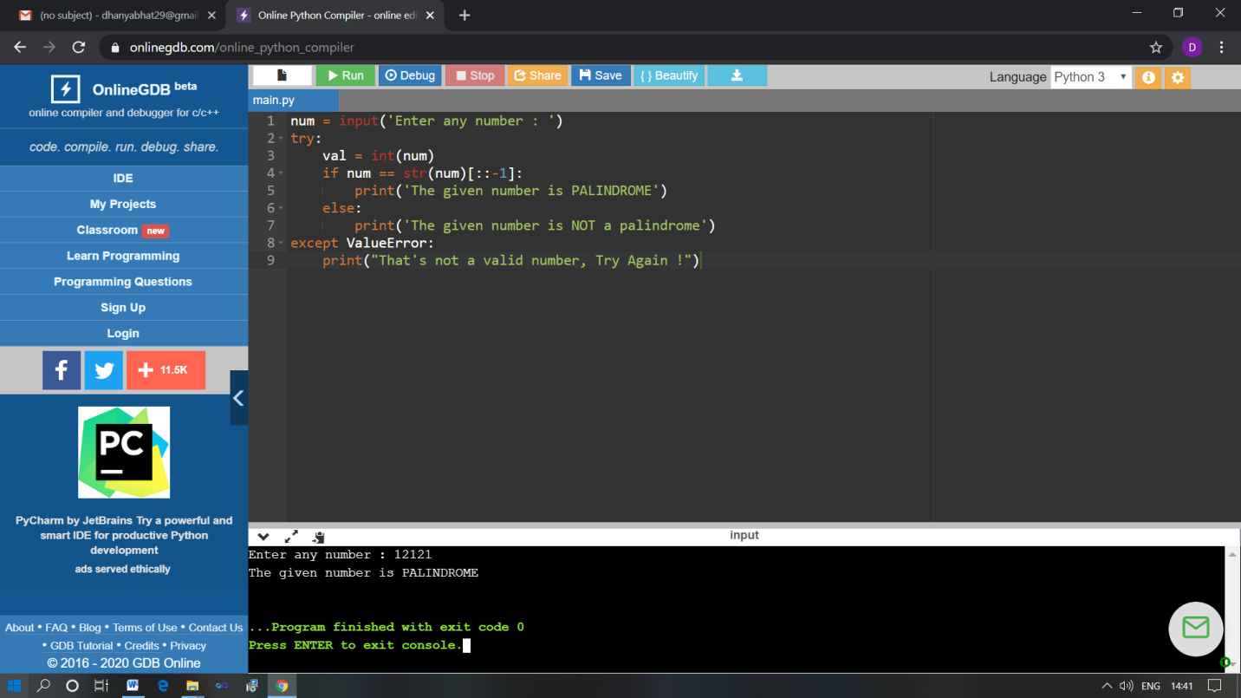

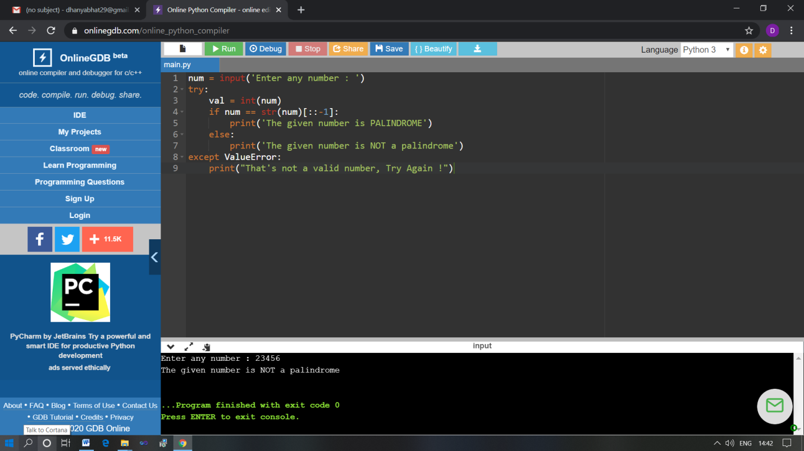

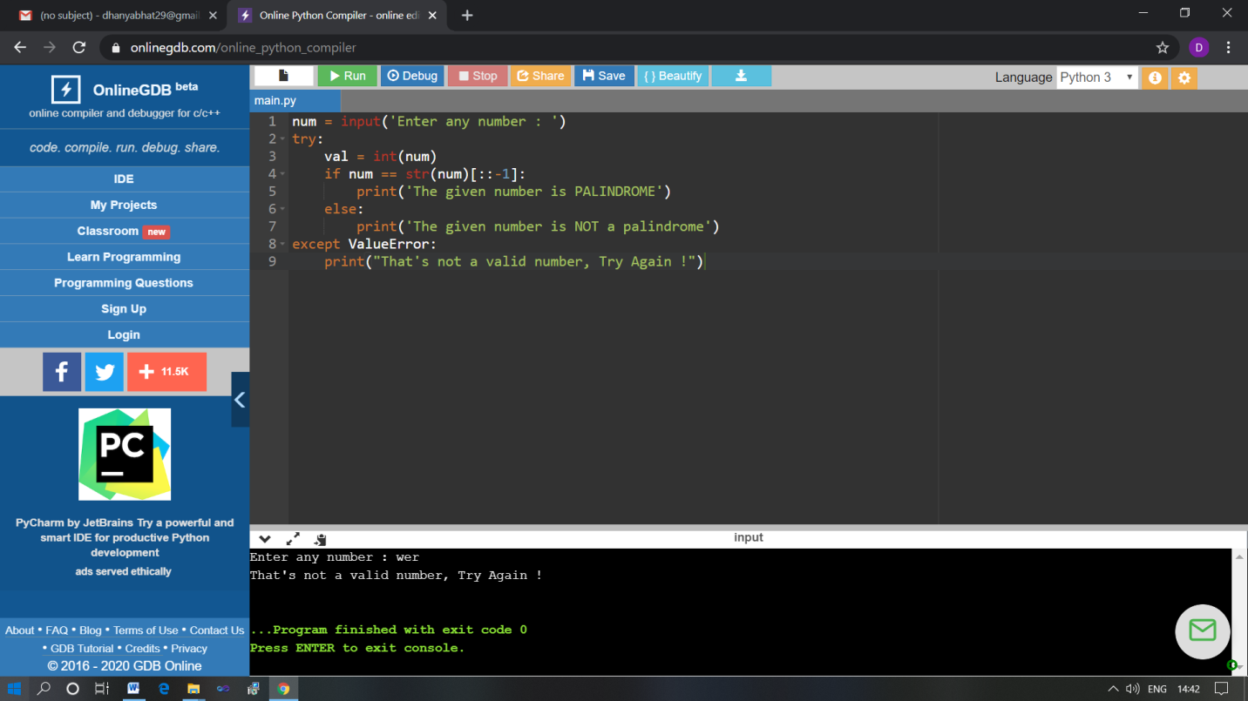

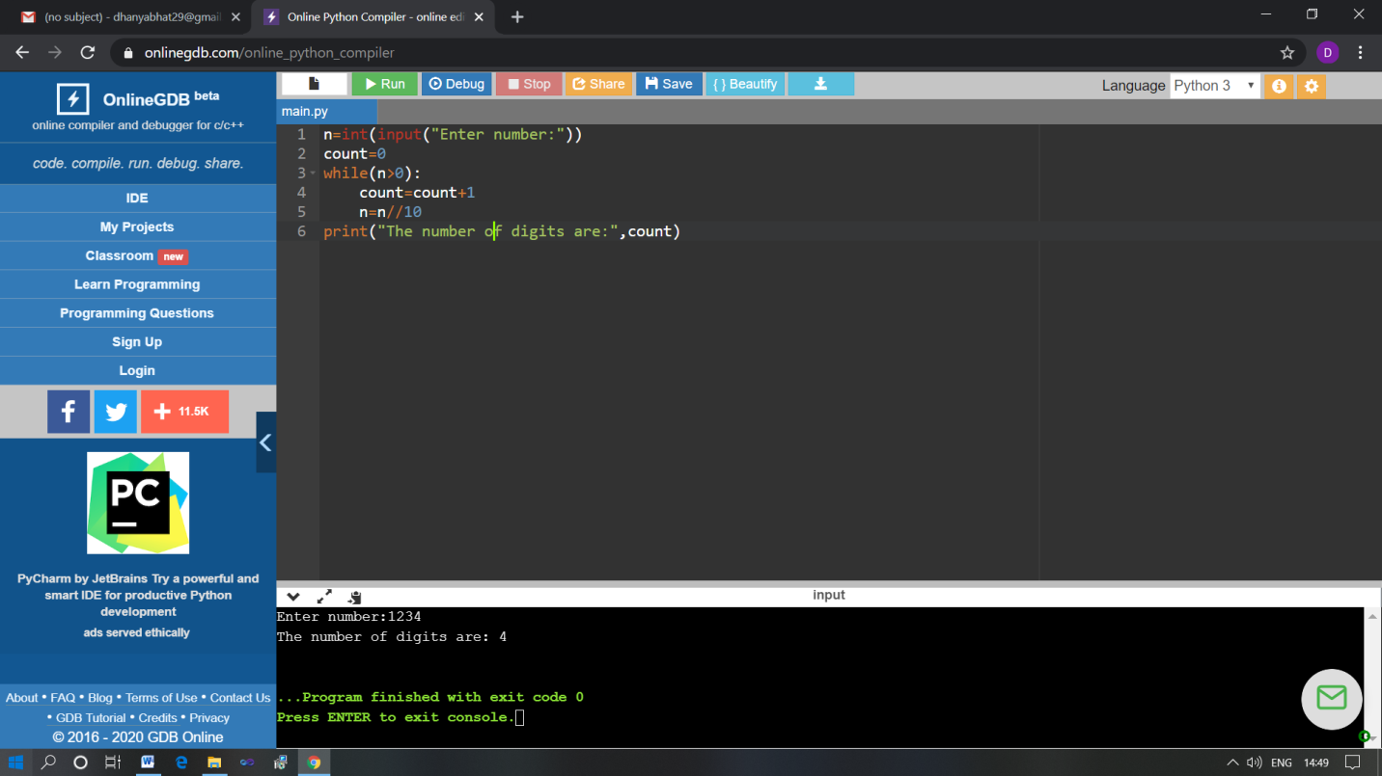

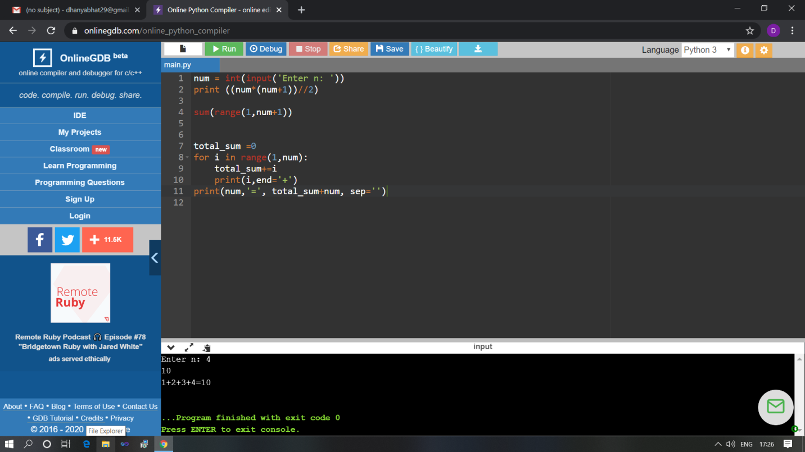

The above Programs were written and executed and the output of the same is displayed above. The code for those 5 programs have been uploaded to the github repository and the link to the same is provided on the form.